# Project Based Learning-II Report

**ON**

**“**TravelMate – A Travel Buddy Finder Website**”**

SUBMITTED TO THE SAVITRIBAI PHULE PUNE UNIVERSITY, PUNE

IN THE FULFILLMENT OF SECOND YEAR OF ENGINEERING

IN

**COMPUTER ENGINEERING**

BY

|  |  |  |
| --- | --- | --- |
| **Sr.No.** | **NAME** | **ROLL NO.** |
| 1. | Arhaan Shaikh | S213027 |
| 2. | Imam Shaikh | S213028 |
| 3. | Sakshi Shelar | S213029 |
| 4. | Sairaj Shilimkar | S213032 |
| 5. | Om Shinde | S213033 |



Zeal Education Society’s

Zeal College of Engineering & Research

Narhe, Pune-411041.

**Zeal Education Society’s**

**Zeal College of Engineering & Research Department of Computer Engineering**



**CERTIFICATE**

This is to certify that Project **TravelMate – A Travel Buddy Finder Website**

|  |  |  |
| --- | --- | --- |
| **Sr.No.** | **NAME** | **ROLL NO.** |
| 1. | Arhaan Shaikh | S213027 |
| 2. | Imam Shaikh | S213028 |
| 3. | Sakshi Shelar | S213029 |
| 4. | Sairaj Shilimkar | S213032 |
| 5. | Om Shinde | S213033 |

are Bonafide students of this institute and the work has been carried out by them under the supervision of **Prof. Komal Bhosale** and it is approved for the partial fulfillment of the requirement of Savitribai Phule Pune University, for the award of Second Year Engineering (Computer Engineering). It is certified that all corrections/suggestions indicated for internal assignment have been incorporated in the report. The project report has been approved as it satisfies the academic requirements in respect of project work prescribed for the Bachelor of Engineering Degree.

**Prof. Komal Bhosale Prof. A. V. Mote**

Project Guide H. O. D

# ACKNOWLEDGEMENT

We take this opportunity to thank our project guide **Prof. Komal Bhosale** and Head of Department **Prof. A. V. Mote** for their valuable guidance and for providing all the necessary facilities, which were indispensable in the completion of this project report. We are also thankful to all the staff members of the Computer Engineering Department for their valuable time, support, comments, suggestions and persuasion. We would also like to thank the institute for providing the required facilities, Internet access and important books.

**ABSTRACT**

TravelMate is a digital platform designed to enhance the travel experience by facilitating connections among like-minded individuals, fostering a vibrant community, and inspiring adventure around the globe. With a focus on user growth, engagement, safety, and sustainability, TravelMate aims to create a secure and inclusive environment where travelers can connect with companions, share experiences, and create lasting memories.

Through strategic partnerships, localized content, and accessibility initiatives, TravelMate seeks to expand its geographical reach and cater to diverse user groups, including solo adventurers, digital nomads, and eco-conscious travelers. By promoting responsible travel practices and environmental stewardship, TravelMate aims to minimize its carbon footprint and support conservation efforts worldwide.

Key objectives include increasing user growth, enhancing user engagement, implementing safety measures, expanding geographical reach, fostering community building, promoting sustainability initiatives, exploring monetization opportunities, and prioritizing user feedback and iteration.

With a commitment to innovation, inclusivity, and user satisfaction, TravelMate is dedicated to empowering travelers to explore the world with confidence, connect with fellow adventurers, and embark on unforgettable journeys together.

**Table of Contents**

**Abstract 4**

**Table of content 5**

**List of Abbreviations 6**

**List of Figures 7**

**List of Tables 8**

|  |  |  |  |
| --- | --- | --- | --- |
| Sr.No. | Content | | Page No. |
| 1 | Introduction | | 9-12 |
|  | 1.1 | Overview | 9 |
|  | 1.2 | Aim/Motivation | 10-11 |
|  | 1.3 | Objective | 11-12 |
| 2 | Literature Survey | | 13 |
| 3 | Problem Statement | | 14 |
| 4 | Software Requirement Specifications | | 15 |
|  | 4.1 | Software Requirements | 15 |
| 5 | System Design | | 16-25 |
|  | 5.1 | Project Block Diagram | 16 |
|  | 5.2 | GUI of Working System | 25 |
| 6 | Conclusion And Future Scope | | 26-28 |
| 7 | References | | 29 |

**List of Abbreviations**

1 PBL – Project Based Learning

2 MERN – MongoDB, Express.js, React.js, Node.js

3 TM – TravelMate

4 TBF – Travel Buddy Finder

**List of Figures**

Figure 1 Project Block Diagram 16

Figure 2 Methodology of the system 23

**List of Tables**

Table 1 Literature Survey 13

**Chapter 1**

**Introduction**

* 1. **Overview**

Welcome to Travel Mate, the ultimate hub for adventurers and wanderers alike. Our platform is more than just a website; it's a thriving community of passionate travelers eager to connect, explore, and share their adventures.

At Travel Mate, we understand that the journey is as important as the destination, and that's why we've curated a range of features to enhance every aspect of your travel experience. From creating personalized profiles to engaging in lively discussions, planning group excursions to discovering hidden gems, Travel Mate is your go-to destination for all things travel-related.

Travel Mate stands out as the premier platform for travel enthusiasts thanks to its community-driven approach, interactive features, and commitment to safety and security. Join Travel Mate today and unlock a world of possibilities as you embark on your next adventure.

Travel Mate is where travelers come together to forge meaningful connections and plan unforgettable trips. Our platform offers a diverse array of features designed to cater to every type of traveler. Whether you're a solo adventurer seeking companionship or a seasoned globetrotter looking to expand your network, Travel Mate provides the tools and resources you need to make your travel dreams a reality. With a user-friendly interface and an active community of like-minded explorers, Travel Mate is the perfect companion for your next journey.

From creating personalized profiles to engaging in lively discussions, planning group excursions to discovering hidden gems, Travel Mate offers a range of features to enhance your travel experience. Explore destinations, connect with fellow travellers, and plan your next adventure with ease.

* 1. **Aim/Motivation**

TravelMate is dedicated to enhancing the travel experience by connecting individuals who share a passion for exploration, discovery, and adventure. Here's a more expanded overview of its aims and motivations:

1. **Facilitating Connections:** TravelMate serves as a digital meeting place where travelers from around the world can connect with one another. Whether you're a seasoned globetrotter or embarking on your first solo trip, TravelMate helps you find compatible travel companions who share your interests, itinerary, and travel style.
2. **Creating Community:** Traveling can sometimes be lonely, especially for solo travelers. TravelMate aims to alleviate this by building a vibrant community of like-minded individuals who are eager to explore new destinations together. Through shared experiences, travelers can forge meaningful friendships and create lasting memories.
3. **Enhancing Safety:** Safety is paramount when traveling, especially in unfamiliar environments. TravelMate provides a platform where users can vet potential travel buddies, exchange information, and plan their adventures collaboratively. By traveling with companions, individuals can feel more secure and confident as they navigate new destinations.
4. **Promoting Diversity and Inclusion:** TravelMate celebrates diversity and aims to create an inclusive environment where travelers of all backgrounds feel welcome. Whether you're young or old, a solo adventurer or a group traveler, TravelMate encourages everyone to connect and share their unique perspectives and experiences.
5. **Encouraging Sustainable Travel:** TravelMate recognizes the importance of responsible and sustainable travel practices. Through its platform, users can find eco-conscious travel buddies who share a commitment to minimizing their environmental impact, supporting local communities, and preserving natural habitats.
6. **Empowering Solo Travelers:** Solo travel can be incredibly rewarding, but it can also be daunting for some individuals. TravelMate empowers solo travelers by offering them the opportunity to connect with companions who can provide support, companionship, and camaraderie along their journey.
7. **Inspiring Adventure:** Ultimately, TravelMate is driven by a passion for adventure and exploration. Whether it's trekking through remote wilderness, immersing oneself in vibrant cultures, or embarking on epic road trips, TravelMate aims to inspire travelers to step out of their comfort zones and embrace new experiences.

By providing a platform that facilitates connections, fosters community, and promotes responsible travel, TravelMate seeks to enrich the lives of travelers everywhere and make the world a more interconnected and accessible place to explore.

* 1. **Objective**

By setting clear objectives and systematically working towards them, TravelMate can achieve its mission of connecting travelers, fostering community, and inspiring adventure in a sustainable and responsible manner.

1. **User Growth:** Increase the number of registered users on the platform by a certain percentage within a defined time frame. This can be achieved through targeted marketing campaigns, partnerships with travel-related businesses, and word-of-mouth referrals.
2. **Engagement:** Boost user engagement by encouraging active participation in the community through features such as forums, discussion groups, and user-generated content sharing. Set goals for the number of interactions per user and track progress over time.
3. **Safety Measures:** Implement safety features such as user verification, rating systems, and in-app messaging to ensure a secure and trustworthy environment for all users. Monitor user feedback and iterate on safety measures to continuously improve the platform.
4. **Geographical Expansion:** Expand the reach of TravelMate by launching in new geographical regions or targeting specific niche markets, such as adventure travelers, solo female travelers, or digital nomads. Develop localized content and partnerships to cater to the needs and interests of diverse user groups.
5. **Partnerships:** Establish partnerships with travel agencies, tour operators, accommodation providers, and other travel-related businesses to offer exclusive deals, discounts, and curated travel experiences to TravelMate users. Negotiate mutually beneficial agreements and track the impact of partnerships on user engagement and revenue.
6. **Accessibility:** Improve the accessibility of the platform by optimizing for mobile devices, enhancing usability for users with disabilities, and providing multilingual support. Conduct user testing and gather feedback to identify areas for improvement and prioritize accessibility initiatives.
7. **Community Building:** Foster a strong sense of community among TravelMate users through organized meetups, group trips, and social events. Encourage users to share their travel stories, photos, and tips with the community, and recognize top contributors through rewards or badges.
8. **Sustainability Initiatives:** Promote sustainable travel practices and environmental stewardship among TravelMate users through educational content, eco-friendly travel tips, and partnerships with environmental organizations. Measure the carbon footprint of user activities and incentivize sustainable behavior through rewards or donations to conservation efforts.
9. **Monetization:** Develop revenue streams through premium subscription plans, sponsored content, affiliate marketing, and commission-based partnerships. Experiment with different monetization strategies and analyze their impact on user acquisition, retention, and overall profitability.
10. **Feedback and Iteration:** Continuously gather feedback from users through surveys, focus groups, and user interviews to identify pain points, usability issues, and feature requests. Prioritize product improvements based on user feedback and iterate on the platform to deliver a better user experience over time.

**Chapter 2**

**Literature Survey**

|  |  |  |  |  |
| --- | --- | --- | --- | --- |
| **Sr.No** | **Research Paper Name** | **Year** | **Author** | **Findings** |
| 1 | Website Design and Development  Using Advance TechnologReact-  JS | 2023 | 1.Rahul chauhan  2.Harish Prasad Semwal  3.Bannilo Fernandes  4.Vinod N. Alone | This article provides an in-depth look at the key features of web applications that enable user interaction, such as flexibility, flexible content, and scalable graphics, effects, and content that can be accessed across multiple platforms. |
| 2 | Hybride Database System of  MongoDB in Web Application  Development | 2020 | 1.Gregorius Ongo  2.Gede Putra Kusuma | The design system can manage names, chat and profiles |
| 3 | Web Design Playground: HTML & CSS The Interactive Way | 2019 | 1.Paul McFedries | This helps us to design the web page of the website |

**Chapter 3**

**Problem Statement**

Solo travel can be thrilling, but many travellers crave companionship to share experiences and enhance safety. Despite the abundance of travel forums and social media platforms, finding a compatible travel buddy remains a challenge. Current options lack efficient matchmaking based on shared interests, travel preferences, and compatibility factors. This gap results in missed opportunities for enriching travel experiences and increased safety concerns for solo travellers.

To address this issue, we propose TravelMate, a dedicated platform designed to match like-minded travellers seeking companionship for their journeys. By leveraging advanced algorithms and user profiles, TravelMate aims to revolutionize the way travellers connect, ensuring meaningful connections, enhanced safety, and unforgettable adventures.

**Chapter 4**

**Software Requirements Specification**

4.1 Software Requirements

* Operating System: Windows, Linux, macOS
* Programming languages: HTML, CSS, JavaScript
* Database Management System: MongoDB
* Software: VS Code, firebase, GitHub
* System: Windows 11

**Chapter 5**

**System Design**

* 1. **Project Block Diagram**

Travelmate operates as a comprehensive platform connecting travelers worldwide by leveraging user-generated profiles and trip details to facilitate compatible travel buddy pairings. Users create profiles outlining their preferences, interests, and personal details, alongside trip specifications such as destination, dates, and budget. Employing a sophisticated matching algorithm, Travelmate suggests potential travel buddies based on factors like location, age, interests, and compatibility scores derived from user-provided data. Through browsing profiles and initiating connections, users can communicate with prospective travel companions, fostering trust and rapport before committing to joint trips. Safety measures, including verification processes and user feedback, ensure a secure environment. Once matches are made, travelers collaborate on trip planning, coordinating logistics, and sharing costs. Throughout the process, Travelmate offers support and assistance, enhancing the overall travel experience and fostering meaningful connections among users.

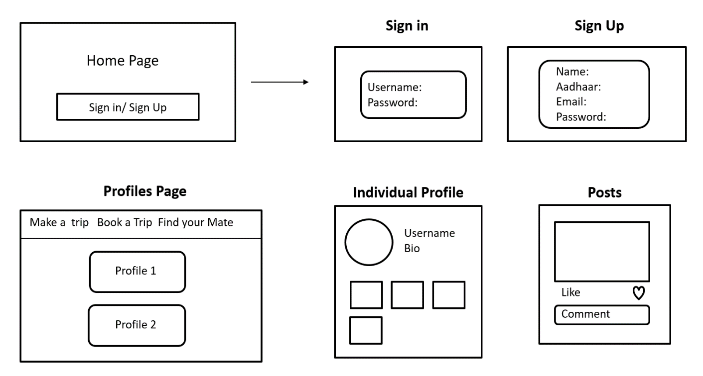

* **Elements of the block diagram:-**

**1.Home page:**

The Home Section of TravelMate's homepage serves as the central hub where users land when they visit the website. It is designed to provide an inviting and informative introduction to the platform, offering users a glimpse into what TravelMate has to offer and guiding them to explore further.

The design of the Home Section is clean, visually appealing, and easy to navigate. It typically features eye-catching imagery of picturesque destinations, adventurous activities, and diverse groups of travelers to capture the imagination of visitors and evoke a sense of wanderlust.

The centerpiece of the Home Section is the Navigation Bar, prominently displayed at the top of the page. This Navigation Bar contains links to various sections of the website, allowing users to easily access key areas such as the About Section, Reviews Section, Safety & Security Section, Terms and Conditions, and Login.

In addition to the Navigation Bar, the Home Section may also include dynamic elements such as a featured trip or destination, a rotating carousel of user testimonials, or a real-time feed of recent activity on the platform. These elements serve to engage users and entice them to explore further.

Overall, the Home Section of TravelMate's homepage is carefully crafted to make a strong first impression, communicate the platform's value proposition, and guide users towards their desired destinations within the site. It contains the information about:

1. **About Section**: Provides an overview of TravelMate, including its mission, values, and features.
2. **Reviews Section**: Contains testimonials and reviews from other travelers who have used TravelMate, building trust and credibility.
3. **Safety & Security Section**: Outlines safety measures and security features implemented by TravelMate to ensure a secure environment for users.
4. **Terms and Conditions**: Contains legal terms and conditions governing the use of the TravelMate platform.
5. **Login**: Provides users with the option to log in to their accounts or create a new account.
6. **Footer**: Includes additional links to important pages such as Privacy Policy, Contact Us, FAQs, and Social Media profiles.

**2.SignUp Page:**

The Signup Page of TravelMate is where new users can create an account to access the platform's features and functionalities. It serves as the gateway for individuals who are interested in joining the TravelMate community and connecting with fellow travelers.

The Signup Page is designed to be user-friendly, intuitive, and inviting, with clear instructions and prompts to guide users through the signup process. It typically consists of several key elements aimed at collecting essential information from users and facilitating account creation.

1. **Registration Form**: The core component of the Signup Page is the registration form, where users are required to provide basic information such as their name, email address, and password. Depending on the platform's requirements, users may also be prompted to provide additional details such as their date of birth, gender, and travel preferences.
2. **Profile Setup**: After completing the registration form, users are typically directed to a profile setup page where they can customize their profile and add more details about themselves. This may include uploading a profile picture, writing a short bio, and specifying their travel interests, destinations, and travel style.
3. **Email Verification**: To ensure the security of user accounts and prevent unauthorized access, TravelMate may require users to verify their email address by clicking on a verification link sent to their registered email. This step helps confirm the validity of the email address provided during registration.
4. **Terms and Conditions**: Similar to the homepage, the Signup Page may also include a section where users are presented with the platform's terms and conditions. By clicking on a checkbox or button, users acknowledge that they have read and agree to abide by the terms and conditions of using TravelMate.
5. **Login Option**: In addition to the signup form, the Signup Page may also include an option for existing users to log in to their accounts if they already have an account with TravelMate. This provides flexibility for users who may have visited the Signup Page by mistake or wish to access their existing account.

Overall, the Signup Page of TravelMate is designed to streamline the account creation process, collect necessary user information, and set the stage for users to start exploring and engaging with the platform's features. It aims to provide a seamless and welcoming experience for new users, encouraging them to become active members of the TravelMate community.

**3.SignIn Page:**

The Sign In Page of TravelMate is where registered users can securely access their accounts by providing their login credentials. It provides a straightforward and efficient means for users to access the platform's features and engage with the TravelMate community.

The Sign In Page is designed to be user-friendly and intuitive, with clear prompts and instructions to guide users through the login process. It typically consists of several key elements aimed at verifying user identity and granting access to their accounts.

1. **Login Form**: The central component of the Sign In Page is the login form, where users are prompted to enter their registered email address or username and password. This information is used to authenticate the user's identity and grant access to their account.
2. **Forgot Password Link**: In case users forget their password, the Sign In Page may include a "Forgot Password" link that allows them to reset their password securely. This link typically leads to a password reset page where users can verify their identity and create a new password.
3. **Remember Me Option**: To enhance user convenience, the Sign In Page may include a "Remember Me" option that allows users to stay logged in on their devices for a certain period. This eliminates the need for users to re-enter their login credentials every time they visit the site, providing a seamless browsing experience.
4. **Social Media Sign In**: For added convenience and flexibility, the Sign In Page may offer the option for users to sign in using their social media accounts such as Facebook, Google, or Twitter. This allows users to access their TravelMate accounts without having to remember additional login credentials.
5. **Sign Up Link**: In case users do not have an existing account, the Sign In Page may include a prominent "Sign Up" link that directs them to the Signup Page where they can create a new account.
6. **Error Messages**: If users enter incorrect login credentials or encounter any other issues during the sign-in process, the Sign In Page may display informative error messages to help users troubleshoot and resolve the issue.

Overall, the Sign In Page of TravelMate is designed to provide a seamless and secure login experience for registered users, enabling them to access their accounts and engage with the platform's features effortlessly. It aims to prioritize user convenience, security, and ease of use, fostering a positive user experience and encouraging continued engagement with the TravelMate community.

**4.Profile Page:**

The "Profile" feature on TravelMate allows users to discover and book trips posted by other users within the TravelMate community. It provides a platform for users to share their travel plans, connect with fellow travelers, and organize group trips. The feature is designed to be interactive, social, and user-friendly, fostering engagement and collaboration among users.

1. **Trip Discovery Feed**: The Trip Discovery Feed is a curated feed of trip posts shared by other users within the TravelMate community. Users can scroll through the feed to discover new and exciting travel opportunities, including group trips, solo adventures, and unique experiences.
2. **Post Interactions**: Each trip post in the Trip Discovery Feed includes interactive features such as likes, comments, and shares. Users can express interest in a trip by liking the post, leave comments to ask questions or share their thoughts, and share the post with their friends or followers.
3. **User Profile Integration**: The Trip Discovery Feed seamlessly integrates with user profiles, allowing users to click on the profile of the trip organizer to learn more about them. Users can view the organizer's profile picture, bio, and trip history, providing valuable context and insights into the trip's organizer.
4. **Trip Details and Booking**: When users click on a trip post in the Trip Discovery Feed, they are taken to a dedicated trip page that provides detailed information about the trip, including the destination, dates, itinerary, and cost. Users can read more about the trip, view photos and reviews from previous participants, and book their spot on the trip directly from the trip page.
5. **Trip Organizer Communication**: Users can communicate directly with the trip organizer through private messages or comments on the trip page. This allows users to ask questions, discuss trip details, and coordinate logistics with the trip organizer before booking their spot on the trip.
6. **Community Engagement**: The "Book a Trip" feature encourages community engagement and collaboration among users. Users can share their own travel plans, organize group trips, and connect with like-minded travelers who share their interests and passions.

Overall, the "profile" feature on TravelMate provides users with a dynamic and interactive platform to discover, book, and participate in group trips organized by fellow travelers. It fosters a sense of community and connection among users, empowering them to explore the world together and create unforgettable travel experiences.

**5.Individual Profile Page:**

The Individual Profile feature on TravelMate provides users with a personalized profile page where they can showcase their travel experiences, connect with other users, and engage with the TravelMate community. It allows users to view posts, followers, following, and follow/unfollow other users, fostering social interaction and collaboration among travelers.

1. **Profile Overview**: The profile page displays an overview of the user's profile, including their profile picture, bio, and basic information such as name, location, and interests. Users can customize their profile by adding additional details such as travel preferences, favorite destinations, and travel bucket list items.
2. **Posts**: The profile page includes a feed of posts shared by the user, showcasing their travel experiences, photos, and stories. Users can scroll through the feed to view posts from the user's travels and adventures, providing inspiration and insights into their travel style and interests.
3. **Followers**: The profile page displays the number of followers the user has, as well as a list of their followers. Users can click on individual follower profiles to view their profiles and connect with them further. This feature allows users to build their network of like-minded travelers and stay connected with fellow members of the TravelMate community.
4. **Following**: Similarly, the profile page also displays the number of users the user is following, as well as a list of the users they are following. Users can click on individual profiles to view their posts and engage with their content. This feature enables users to discover new travel inspiration and connect with other users whose travel experiences resonate with them.
5. **Follow/Unfollow**: Users have the option to follow or unfollow other users directly from their profile page. By clicking on the follow button, users can subscribe to updates from the user and stay informed about their travel adventures. Conversely, users can unfollow other users if they no longer wish to receive updates from them.

Overall, the Individual Profile feature on TravelMate provides users with a personalized space to showcase their travel adventures, connect with other users, and engage with the TravelMate community. It promotes social interaction, collaboration, and inspiration among travelers, empowering them to explore the world together and create meaningful connections along the way.

**6.Posts:**

The Posts Section on TravelMate allows users to create and share their travel experiences, photos, and stories with the TravelMate community. It serves as a platform for users to inspire others, document their adventures, and connect with fellow travelers from around the world.

1. **Create Post Form**: The heart of the Posts Section is the Create Post Form, where users can compose their own posts by uploading photos, writing captions, and adding details about their travel experiences. The form may include fields for users to specify the destination, date of the trip, and any additional information they wish to share.
2. **Media Upload**: Users can upload photos or videos from their travels directly from their devices or select images from their existing galleries. The media upload feature supports multiple file formats and allows users to add captions or descriptions to accompany their visuals.
3. **Text Content**: In addition to media uploads, users can write text content to provide context, share anecdotes, or offer travel tips related to their posts. The text editor may include formatting options such as bold, italic, and bullet points to enhance readability and visual appeal.
4. **Post Preview**: Before publishing their posts, users can preview how their posts will appear to others to ensure they are satisfied with the layout, formatting, and content. The post preview feature allows users to make any final adjustments before sharing their posts with the TravelMate community.

Overall, the Posts Section on TravelMate provides users with a creative outlet to share their travel experiences, connect with other travelers, and contribute to the vibrant and dynamic TravelMate community. It empowers users to showcase their adventures, inspire others, and celebrate the joy of travel in all its forms.

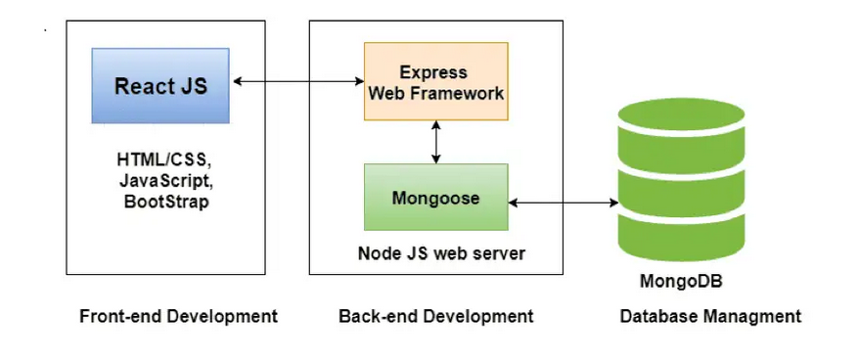

**Methodology**

The MERN stack, consisting of MongoDB, Express.js, React, and Node.js, provides a powerful and efficient framework for developing the Posts Section feature on TravelMate. Here's how each component of the MERN stack contributes to the functionality of the feature:

1. **MongoDB**: MongoDB serves as the database for storing user-generated content, such as posts, comments, likes, and user profiles. It provides a flexible and scalable data model that can accommodate various types of media, including images, videos, and text.
2. **Express.js**: Express.js is used to create a RESTful API that handles CRUD (Create, Read, Update, Delete) operations for managing posts, comments, and user profiles. It acts as the backend server framework, handling HTTP requests and responses, routing, and middleware functionality.
3. **React**: React is utilized to build the user interface for creating, viewing, and interacting with posts. It enables the creation of dynamic and responsive UI components, such as forms for creating posts, feed displays for viewing posts, and interactive features for liking, commenting, and sharing posts.
4. **Node.js**: Node.js serves as the runtime environment for executing server-side JavaScript code. It powers the backend server that communicates with the MongoDB database, processes requests from the frontend, and serves data to the React-based user interface.

Here's how the MERN stack workflow would operate for the Posts Section feature on TravelMate:

1. **Frontend Development with React**: Developers use React to create the user interface components for the Posts Section, including forms for creating posts, feed displays for viewing posts, and interactive features for liking, commenting, and sharing posts. React components are modular and reusable, enabling efficient development and maintenance of the frontend.
2. **Backend Development with Express.js and Node.js**: Developers use Express.js to create a RESTful API that handles CRUD operations for managing posts, comments, likes, and user profiles. Node.js serves as the runtime environment for executing server-side JavaScript code, enabling developers to build a scalable and performant backend server that communicates with the MongoDB database.
3. **Database Management with MongoDB**: Developers use MongoDB to store and manage user-generated content, such as posts, comments, likes, and user profiles. MongoDB's flexible and scalable data model accommodates various types of media, making it well-suited for storing multimedia content associated with travel posts.
4. **Integration and Testing**: Once the frontend and backend components are developed, developers integrate them together to create a cohesive and functional application. They conduct thorough testing to ensure that the application performs as expected, handles user interactions gracefully, and maintains data integrity across the frontend and backend components.
5. **Deployment and Maintenance**: After testing, the application is deployed to a production environment where it is made available to users. Developers monitor the application's performance, address any issues that arise, and implement updates and improvements as needed to ensure a seamless user experience.

Overall, the MERN stack provides a comprehensive and efficient framework for developing the Posts Section feature on TravelMate, enabling developers to build a dynamic and interactive platform for sharing travel experiences, connecting with other travelers, and contributing to the vibrant TravelMate community.

**5.2 GUI of Working System**

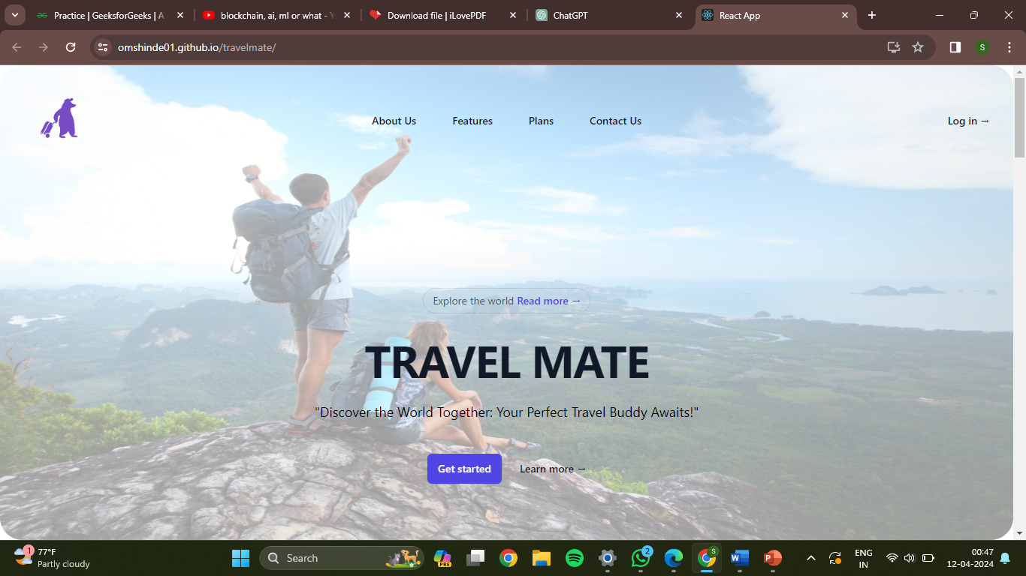

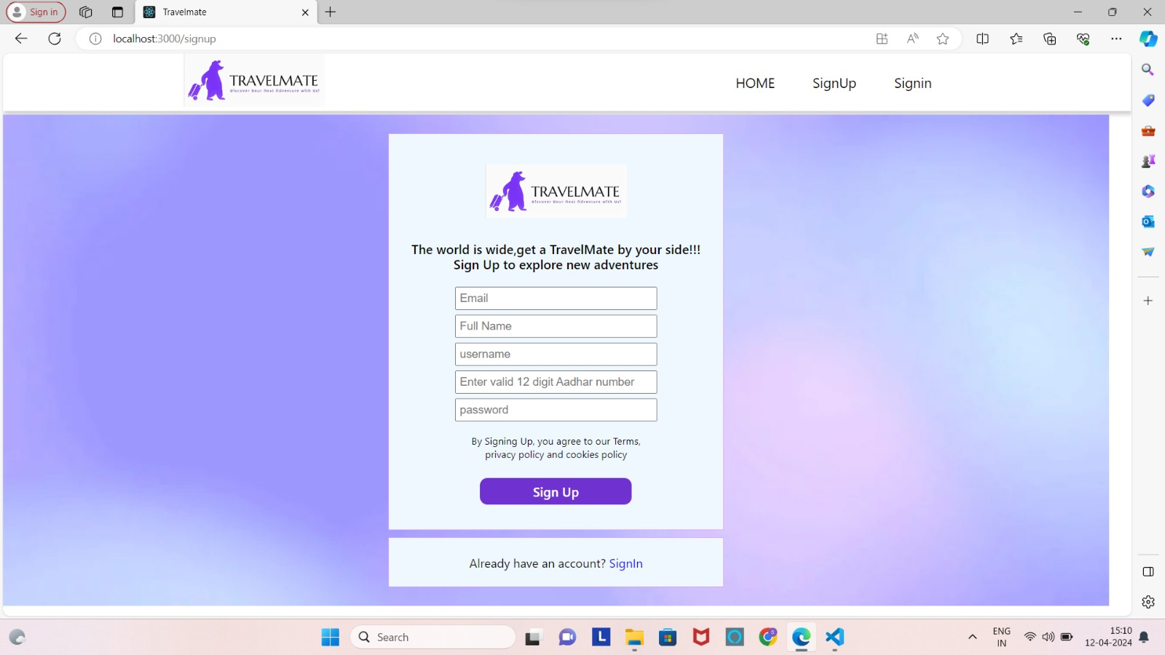

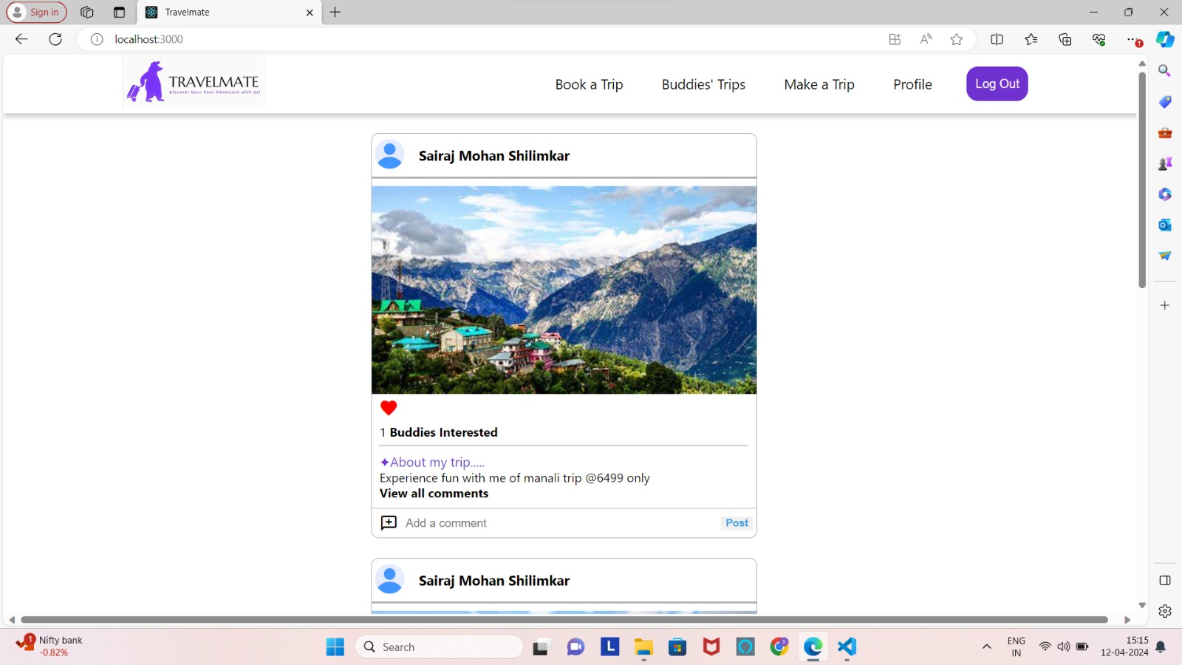

**Chapter 6**

**Conclusion and Future Scope**

**Conclusion:**

In conclusion, TravelMate stands as a pioneering solution for the contemporary traveler, seamlessly connecting individuals with compatible travel companions and amplifying the joy of exploration. Through its user-centric approach and innovative features, TravelMate facilitates meaningful connections, fosters collaboration, and inspires unforgettable adventures.

1. **Efficient Matching:** TravelMate streamlines the process of finding travel buddies by employing advanced matching algorithms and user preferences. By considering factors such as destination preferences, travel dates, and interests, TravelMate ensures compatibility and enhances the likelihood of successful travel partnerships.
2. **User-Friendly Interface:** With its intuitive interface and easy navigation, TravelMate offers a hassle-free experience for users to search, connect, and plan trips. The platform's simplicity and accessibility make it appealing to travelers of all ages and backgrounds, fostering inclusivity and diversity within the community.
3. **Safety and Security:** TravelMate prioritizes the safety and security of its users, implementing robust verification measures and providing resources for informed decision-making. By verifying user profiles and offering trip feedback mechanisms, TravelMate creates a trustworthy environment where travelers can feel confident in their interactions and arrangements.
4. **Community Building:** TravelMate cultivates a vibrant community of travelers who share experiences, exchange insights, and forge meaningful connections. Through its social features, discussion forums, and group activities, TravelMate fosters a sense of belonging and camaraderie among its users, enriching the travel experience and creating lasting friendships.

In essence, TravelMate is more than just a travel companion—it's a gateway to new experiences, a catalyst for connection, and a beacon of inspiration for travelers worldwide.

**Future Scope:**

The future scope of TravelMate holds immense potential for growth, innovation, and impact within the travel industry. Here are several areas where TravelMate can expand and evolve:

1. **Global Expansion**: TravelMate can broaden its reach by expanding its geographical coverage to include more destinations worldwide. By catering to travelers from diverse regions and cultures, TravelMate can become a truly global platform for connecting adventurers and fostering cross-cultural exchanges.
2. **Enhanced Features and Technology**: Continuously evolving technology offers opportunities to enhance TravelMate's features and user experience. Integration of augmented reality (AR) for virtual tours, artificial intelligence (AI) for personalized trip recommendations, and blockchain for secure transactions are just a few examples of how TravelMate can leverage emerging technologies to stay at the forefront of innovation.
3. **Partnerships and Collaborations**: Collaborating with travel agencies, airlines, hotels, and local businesses can enrich TravelMate's offerings and provide users with exclusive deals, discounts, and experiences. Strategic partnerships can also facilitate the integration of additional services such as transportation, accommodation, and guided tours, enhancing the overall travel experience for users.
4. **Community Engagement and Events**: Organizing community events, meetups, and group trips can strengthen TravelMate's community and foster deeper connections among users. By facilitating offline interactions and shared experiences, TravelMate can create opportunities for meaningful connections and lifelong friendships among travelers.
5. **Sustainability Initiatives**: With growing awareness of environmental sustainability, TravelMate can incorporate sustainability initiatives into its platform. This may include promoting eco-friendly travel practices, supporting conservation efforts, and facilitating carbon offsetting options for travelers, aligning with the growing demand for responsible and sustainable travel experiences.
6. **Mobile Application Development**: Developing a dedicated mobile application for TravelMate can enhance accessibility and convenience for users, allowing them to access the platform on-the-go and stay connected during their travels. A mobile app can offer features such as real-time notifications, offline access to trip details, and location-based recommendations, providing a seamless and personalized user experience.
7. **Monetization Strategies**: Implementing various monetization strategies such as premium memberships, sponsored content, advertising partnerships, and commission-based referrals can generate revenue for TravelMate while providing additional value to users. Careful consideration of monetization strategies ensures that they align with TravelMate's mission and enhance the user experience rather than detracting from it.

Overall, the future of TravelMate is filled with possibilities for growth, innovation, and positive impact within the travel industry. By staying agile, responsive to user feedback, and mindful of emerging trends, TravelMate can continue to evolve as a trusted companion for travelers worldwide, empowering them to explore the world with confidence, connect with fellow adventurers, and create unforgettable memories along the way.

Top of Form

**References**

1. **Gretzel, U., & Yoo, K. H.** *Use and Impact of Online Travel Reviews.* Information and Communication Technologies in Tourism, Springer, Vienna, Austria, 2008.
2. **Xiang, Z., & Gretzel, U.** *Role of Social Media in Online Travel Information Search.* Tourism Management, 31(2), 179-188, 2010.
3. **Huang, Z., & Benyoucef, M.** *From E-Commerce to Social Commerce: A Close Look at Design Features.* Electronic Commerce Research and Applications, 12(4), 246-259, 2013.
4. **Jiang, Z., & Benbasat, I.** *Research Note: Investigating the Influence of the Functional Mechanisms of Online Product Presentations.* Information Systems Research, 15(1), 32-55, 2004.
5. **Kim, D., & Fesenmaier, D. R.** *Persuasive Design of Destination Recommendation Systems: An Analysis of User Preferences and Motivation.* Information Technology & Tourism, 17(4), 373-390, 2017.